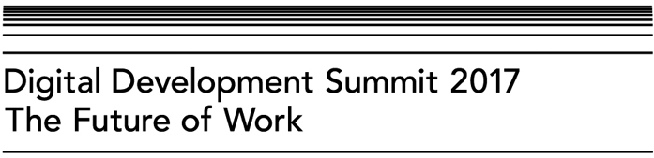
We value your feedback and would be grateful if you could take five minutes to complete this event evaluation form. The information you provide will be reviewed by Summit organisers and used to shape future work and events.

1. Name:

2. Gender:

3. Country of residence:

4. What is your main role?
Academic / researcher | □
Civil society actor | □
Donor | □
Government actor | □
Knowledge broker / intermediary | □
NGO practitioner | □
Policy maker | □
Private sector actor | □
Other :

5. To what extent did the event achieve the following objectives:
 | Strongly disagree | Disagree | Neither disagree nor agree | Agree | Strongly Agree
It facilitated dialogue and discussion on the challenges and opportunities for how the digital revolution might influence development progress on jobs, employment and livelihoods. | □ | □ | □ | □ | □
It built a collective agenda for how to ensure the future of our work is inclusive, sustainable and leaves no one behind. | □ | □ | □ | □ | □
It bridged academic, policy and practitioner communities across issues relevant to digital development trends and achievement of SDGs. | □ | □ | □ | □ | □
Comment:

6. Did you make new connections or strengthen existing relationships at this event?
Yes | □
No | □

6a. If yes, please estimate the number of new/strengthened connections as a result of your participation in the event:
Answer:
Comment:

7. To what extent was the research presented in the keynote speeches at the Digital Development Summit relevant to your work?
Not at all relevant
Partially relevant
Completely relevant
Comment:

8. What were the least useful aspects of the event to you and why?

9. What were the most useful aspects of the event to you and why?

10. This year’s Summit theme was The Future of Work. What do you think the theme should be for the 2018 Summit?

11. How did you hear about the event?

12. Are you an ESRC-DFID grant holder or grant partner?
Yes | □
No | □

13. Would you like to subscribe to the IDS Digital and Technology e-newsletter?
Yes | □
No | □
If yes, please provide your email address:

Thank you!

