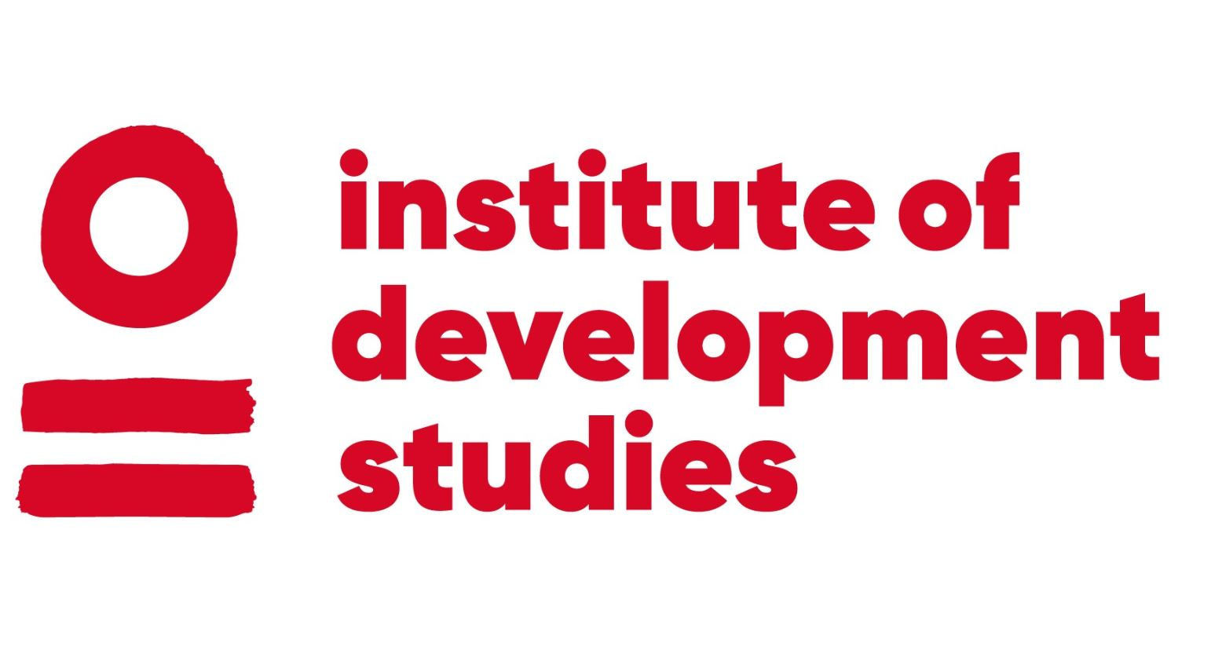 | CURRICULUM VITAE  Colin Anderson

Institute of Development Studies E: c.anderson2l@ids.ac.uk
Library Road T: +44 (0)1273 606261
Brighton W: www.ids.ac.uk
BN1 9RE
UK

CURRENT EMPLOYMENT: Research Officer
DATE OF BIRTH: 16/01/1980
NATIONALITY: British
LANGUAGES: English
THEMATIC EXPERTISE: Citizen-State Relations; Transparency & Accountability; Development Assistance and the
Politics of Development; Decentralisation and Local Governance; Education and Youth
Services; Public Sector Reform and Policy Processes; Fragility and Conflict
GEOGRAPHICAL EXPERTISE: South-East Asia; Myanmar; Cambodia; UK

OVERVIEW
Colin Anderson is an IDS Research Officer working across a portfolio that explores what drives changes in citizen-state relationships, with a particular focus on the role of international actors and citizen-led social and political action. Drawing on a career in public sector and civil society reform and advocacy, his work explores pathways to better governance relationships and more inclusive societies. His professional experience includes participatory community development, public sector reform, strategic development, and evidence generation and uptake. He has particular expertise in local governance relationships, education and youth service reform, and civil society mobilization and advocacy. At IDS he supports projects examining the ways in which more inclusive and equitable governance relationships are built and sustained. His current research focuses on social and political action and development interventions that seek to enhance or claim public accountability and responsive governance. This includes in contexts of fragility and conflict and the ways in which development actors and policies seek to build the social contract. His approach to this is theoretically grounded in postgraduate study of cultural politics, governance, and public policy processes, and
linked to his practice in civil society strengthening and public policy reform.

EDUCATION AND QUALIFICATIONS
2016 – 2017 MA Governance, Development & Public Policy
Institute of Development Studies, UK
2002 – 2004 MA Cultural Politics
University of Sussex, UK
1998 – 2001 BA (Hons) English Language and Literature
Somerville College, University of Oxford, UK

RECORD OF EMPLOYMENT
2017 – PRESENT Research Officer IDS, UK
Supporting IDS research programmes exploring citizen-state relationships and pathways to more inclusive and accountable governance on multiple projects, including research design and fieldwork, learning accompaniment to development programmes, academic output production and editing, and research programme management.
2015 – 2017 Freelance Consultant
Undertaking strategic reviews and supporting strategic development and quality of research and evidence generation for government and civil society organisations in the UK and Cambodia.
2014 – 2015 Advocacy & Donor Relations Advisor, NGO Education Partnership, Cambodia
Supporting organizational strategic and programme development and building capacity for advocacy and evidence-based influencing of government with the national coalition of education NGOs.
2008 – 2014 Policy & Programme Manager, Children’s Services Department, East Sussex
County Council, UK
Developing and implementing inter-agency strategies, joint commissioning, and service reform to improve educational and social welfare outcomes for children and young people.
SELECTED PUBLICATIONS
2022 Co-author: Researching governance in difficult times and places: Reflections from Mozambique, Myanmar, Nigeria and Pakistan.
2022 Lead author: Against the Odds – Action for Empowerment and Accountability in Challenging Contexts. Final report of the 5-year A4EA research programme on social and political action in contexts affected by conflict and violence.
2021 Co-lead: Understanding governance from the margins – what does it mean in practice? Policy and practice oriented paper, summarising findings of and implications from the 4 year Governance Diaries and Governance at the Margins research project.
2021 Lead author: Navigating Civic Space in a Time of Covid: Synthesis Report. Final report of research in Mozambique, Nigeria and Pakistan on the impact of Covid-19 on civic space and conditions for civic activism.
2020 Lead author: How Do Donor-led Empowerment and Accountability Activities Take Scale into Account? Evidence from DFID Programmes in Contexts of Fragility, Conflict and Violence. Cross-country comparative analysis of DFID programmatic approaches to building pathways to accountability in fragile and conflict affected settings.
2016 Co-author: Teaching Hours in Cambodian Primary Schools. Research report on extent and drivers of teacher absence and unofficial school closures, and suitable policy responses.
SELECTED EXPERIENCE
2019 - 2021 Programme research officer, ‘Learning with SPARK’ action research partnership.
Working with the International Budget Partnership to support action research accompaniment alongside their support to grassroots campaigns in seven countries for increased access to services for marginalised or minoritised groups, with a focus on inclusive fiscal governance.
2017 – 2022 Programme research officer, Action for Empowerment and Accountability research programme. Support to a portfolio of research on social and political action in contexts affected by conflict and fragility, including researcher training and support, organising consortia knowledge-sharing, organising comparative analysis, and synthesising programme findings.
2019 Mid-term evaluation of ‘Deepening Social Accountability in Myanmar’ programme (for Oxfam in Myanmar).
2018 Evidence and Learning for donor local governance programming in Myanmar.
Contribution to the evidence and learning facility with the DFID-funded programme ‘Supporting Partnerships for Accountability and Civic Engagement’.
2015 Advocacy-oriented research on Cambodian education system
Institutional and research support to publication of influential policy-oriented studies on teacher absence and instructional hours, public expenditure tracking, teacher deployment, and teacher professional development based on NGO-led primary fieldwork.

