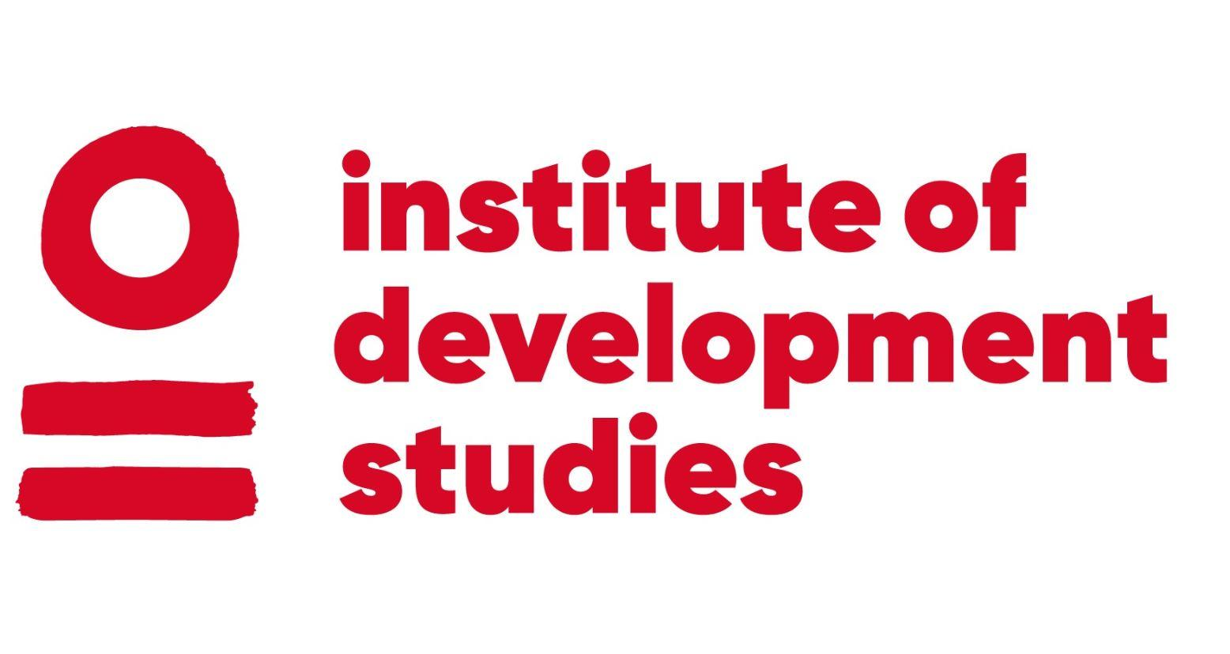 | CURRICULUM VITAE  Stephen Gray

Institute of Development Studies E: s.gray@ids.ac.uk
Library Road T: +44 (0)1273 606261
Brighton W: www.ids.ac.uk

CURRENT EMPLOYMENT: Adapt Peacebuilding, Director
DATE OF BIRTH: 25/05/1981
NATIONALITY: New Zealander
LANGUAGES: English, Spanish
THEMATIC EXPERTISE: Peacebuilding; power and agency; peace process design; inclusive peacebuilding; mediation and dialog; facilitation; conflict analysis; complex adaptive systems; peacetech; conflict sensitivity; peacebuilding and natural resources;
GEOGRAPHICAL EXPERTISE: Myanmar, Colombia, United States of America
OVERVIEW
I am a researcher and international affairs professional specializing in peacebuilding innovation. For 15 years I have worked on peacebuilding issues for multilateral organisations, governments, NGOs, academic institutions, and private companies on four continents. Particular focuses include participatory, systems and complexity approaches to peacebuilding research, policy and programming. My PhD research concerns roles, power and relationships between local and international peacebuilders. I am an experienced author, adviser, volunteer, facilitator, trainer, researcher, podcaster, lecturer and mediator. I direct the social enterprise Adapt Peacebuilding and hold a Masters in International Affairs from Columbia University. See more on www.adaptpeacebuilding.org.
EDUCATION AND QUALIFICATIONS
2021 - PhD in Development Studies
Institute for Development Studies, University of Sussex, UK
2009 - 2011 Masters of International Affairs (International Conflict Resolution)
Columbia University, USA
2011 Certificate in Mediation (Alternative Dispute Resolution)
New York Peace Institute, USA
2000 - 2004 Bachelor of Science (Genetics), Postgraduate Diploma in Science (Biotechnology)
Otago University, New Zealand

RECORD OF EMPLOYMENT
Mar 2013 – Present Director, Adapt Peacebuilding, Global
Adapt Peacebuilding provides programming, accompaniment, and knowledge creation for peacebuilding innovation. As Director I design, implement, and manage staff and programs that have totaled approximately USD$800,000 across four continents since 2015. https://adaptpeacebuilding.org/. In 2021 Adapt is implementing peacebuilding programs in Myanmar and Colombia worth $400,000 and is providing advisory services globally on systems and complexity approaches to peace.
Dec 2020 – Present Adviser, Conducive Spaces for Peace, Global
Expert advice to a global research project research on support to “local peacebuilding”.
Nov 2018 – Present Adviser, Christian Aid Ireland, Global
Together with Andy Carl, this three-year project supports CAI to implement, learn from, and disseminate findings related to the application of adaptive programming across its peacebuilding, gender, governance and human rights work in seven countries.
Dec 2019 – Dec 2020 Lead Adviser, Search for Common Ground, United Nations, Myanmar
Lead adviser regarding conflict sensitivity and inclusion for UNDP’s Rakhine Based Area Programme.
Sep 2019 – Mar 2020 Adviser, Unidad Busqueda Personas Desaparecidos, Colombia
Support to this Colombian government unit to apply adaptive programming approaches to the search for ‘disappeared persons’ from Colombian’s civil war. I oversee design and implementation.
Jul 2019 – Sep 2019 Adviser, Esquerra Republicana Catalunya, Spain
This process advises a pro-independence Catalonian political party to develop strategy in the context of protracted conflict and negotiation with the Spanish State on the question of Catalonian independence.
May 2019 – Jul 2019 Lead Adviser, Myanmar Peace Support Fund (Paung Sie Facility), Myanmar
Lead adviser on social cohesion analysis to advise on theories of change and programming direction for this multi-donor fund.
Jan - Jun 2019 Researcher, Mercy Corps, USA
Researched the weaponization of social media (hatespeech, information operations, political manipulation, violent extremism) and analyzed its emerging implications for violent conflict. Produced an analytical report and explored programming responses.
May 2018 – Mar 2019 Systems Coach, Fundación Ideas para la Paz, Colombia
Acted as a systems coach for this peacebuilding think tank, supporting the adoption of systems practice as a research methodology, to develop organizational strategy, and to promote systems concepts and tools for peacebuilding in Latin America.
Sep 2017 – Dec 2018 Researcher, International Alert, UK, Myanmar
Prepared a report on risks and opportunities for peacebuilding utilizing natural resource management. Facilitated a multi-stakeholder strategy workshop and briefed donors.
Sep 2017 - Dec 2017 Analyst, United Nations Office on Drugs and Crime, Myanmar
Conducted conflict sensitivity analysis of UNODC’s corruption program in Myanmar and trained staff.
Jan 2017 – Dec 2017 Adviser, Humanity United, USA
Provided advice to this donor organization in regards to their global Transforming Peacebuilding Strategy, especially as concerns the methodology underpinning their multi-year Mali programme.
Mar 2017 – Oct 2017 Adviser, International Finance Corporation, Myanmar
Conducted a conflict, sub-basin vulnerability, and project impact assessments of Myanmar’s hydropower sector, providing detailed recommendations for conflict-sensitive hydropower development.
Sep 2015 – Aug 2017 Strategic Adviser, Hope International Development Agency, Myanmar
Provided research, advice, and project implementation to support ethnic armed organisations, civil society organisations, and international donor partners in relation to Myanmar’s peace process. Supported fundraising and M&E. Lead strategies for responsible natural resource management to strengthen relationships between state and non-state actors.
Jul 2014 – Sep 2015 Senior Country Adviser, Envisage, Myanmar
Envisage advises clients on power, peace, natural resources and civil society in Myanmar. I represented the company, managed the team, led client engagement, direct the research, shaped the analysis, and presented the work.
Aug 2014 – Sep 2015 Adviser, Common Space Initiative, Myanmar
I supported Hannes Siebert in his work with political stakeholders in Myanmar to negotiate frameworks for the proposed national political dialog. Co-designed the incoming NLD government’s peace process roadmap with Nobel laureate Aung San Suu Kyi.
Jun 2013 – Sep 2014 Trainer, Ethnic Peace Resources Project, Myanmar
The EPRP provides knowledge for ethnic actors in Myanmar’s peace process. I trained ceasefire liaison officers and ethnic CSOs and developed materials for online and offline capacity development activities.
Oct 2013 – Oct 2014 Project Director, Columbia University, New York, Myanmar
Directed a Systemic Action Research to support public participation in Myanmar’s peace process. As Project Director I secured funding, built and managed the team, oversaw implementation, provided technical assistance, and disseminated findings.
Jan 2014 – Mar 2014 Trainer Designer, United Nations Development Programme, Myanmar
Designed the inaugural Myanmar Police Force training on conflict sensitivity, delivered over 3 days to senior officials.
Jun 2013 – Oct 2013 Trainer and Advisor, United Nations Children’s Fund (UNICEF), Myanmar
Provided a conflict lens to UNICEF Myanmar’s Mid Term Review, including trainings on conflict sensitivity for senior management and local staff, and recommendations to improve peacebuilding.
Mar 2013 – Sep 2014 Adviser, Myanmar Peace Support Initiative, Myanmar
This initiative of the Norwegian government worked to support Myanmar ceasefire implementation. I worked as coordinator, managed support to ceasefire liaison offices, and advised donors.
Mar 2013 – Aug 2013 Adviser, United States Institute of Peace, USA, Myanmar
Conducted a media and conflict assessment and recommended peacebuilding interventions.
Nov 2012 – Mar 2013 Adviser, United Nations Office of the Resident Coordinator, Myanmar
Conducted a nationwide Peace and Conflict-Sensitive Development Analysis, providing recommendations to reshape agencies’ priorities with respect to conflict sensitivity and peacebuilding.
Nov 2011 – May 2012 Project Manager, United Nations Department of Peacekeeping Operations, USA
Managed projects for the Office of Rule of Law and Security Institutions (OROLSI), tracking deliverables, managing consultants, chairing inter-agency meetings, and providing input to training programs.
May 2011 – Sep 2011 Researcher, IDS International, South Sudan
Undertook market research and helped establish operations for this security sector reform company.
May 2010 – Aug 2011 Researcher, United Nations, USA, Cambodia, Liberia, South Sudan
Conducted research for DPKO’s “Civil Affairs Handbook”, evaluated UNDP Cambodia’s trade program, analysed field reporting for DPKO’s best practices section, edited the “Civilian Capacities Review” for the Peacebuilding Support Office, provided recommendations on UNMIL’s drawdown, and published articles for UNICEF South Sudan.
Jun 2008 – Jul 2009 Process Designer and Trainer, Pangaea Consulting, New Zealand
For the Ministry of Education I re-designed the operational process to establish new schools in New Zealand and provided related training nationwide. For the Ministry of Housing I drafted and edited the Minister’s personal correspondence.
Sep 2007 – Dec 2007 Adviser, New Zealand Permanent Mission to the United Nations, USA
Provided diplomatic support during the 2007 General Assembly, including reporting on Security Council, General Assembly, third, and fourth committee proceedings. Developed networks, supported visiting dignitaries, and presented New Zealand’s position in multilateral negotiations.

Jan 2007 – Sep 2007 Policy Analyst, Ministry of Research, Science and Technology, New Zealand
Lead an interagency team to shape public policy in relation to national research, science and technology investments. Designed an innovative online project to gather public information for New Zealand’s sustainability research agenda.
Jan 2005 – Dec 2006 Policy Analyst, Tertiary Education Commission, New Zealand
Lead an interagency team to shape public policy in relation to national research, science and technology investments. Designed an innovative online project to gather public information for New Zealand’s sustainability research agenda.
Jan 2004 – Dec 2004 Campaign Assistant, World Vision, New Zealand
Helped design and implement fundraising activities associated with the 40-hour famine campaign, including signing up students on campus and promoting the campaign via public stunts, digital communication and public speaking.
SELECTED EXPERIENCE
Mar 2013 – Present Director, Adapt Peacebuilding, Global
Adapt Peacebuilding provides programming, accompaniment, and knowledge creation for peacebuilding innovation. As Director I design, implement, and manage staff and programs that have totaled approximately USD$800,000 across four continents since 2015. https://adaptpeacebuilding.org/. In 2021 Adapt is implementing peacebuilding programs in Myanmar and Colombia worth $400,000 and is providing advisory services globally on systems and complexity approaches to peace.
SELECTED PUBLICATIONS AND OUTPUTS
Burns D.; Gray, S. (2020) “Local agency, adaptation, and vertical integration of bottom-up peacebuilding”, Peacebuilding
Gray, S. (2019) “The weaponization of social media and implications for violent conflict”, Mercy Corps
Gray, S. (2019) “Rapid Analysis of Social Cohesion in Kachin and Shan States”, Peace Support Fund, Myanmar
de Coning C.; Gray, S. (2018) “Adaptive Mediation”, ACCORD
Gray, S. (2018) “Forest Management and Peacebuilding in Karen Areas of Myanmar,” International Alert
Gray, S.; Salih, C. (2017) “Low Cohesion in Non-State Armed Groups: Implications and Strategies for Mediators”, USIP
Gray, S.; Joshi, M; Lederach, J.P. (2017) “Can Myanmar’s Peace Process learn from International Experience”, Frontier
Gray, S. (2017) “Peace and Conflict Chapter: Baseline Assessment for Myanmar’s Hydropower SEA”, IFC
Gray, S. (2016) “Myanmar’s new government: intentions still unclear”, Lowy Interpreter
Gray, S. (2015) “Intercommunal Conflict in Mandalay Region and Southern Shan State”, Mercy Corps
Gray, S.; Roos J. (2014) “Intercommunal Violence in Myanmar: Risks and Opportunities”, Mercy Corps
Gray, S., Dolan, T. (2014) “Media and Peacebuilding in Myanmar”, USIP
Gray, S. (2014) “The one place where Washington can make a difference”, Foreign Policy
Gray, S. (2013) “UNICEF Myanmar: Peacebuilding and Conflict Sensitivity”, UNICEF Myanmar
Gray, S. (2013) “Peace and Development Conflict Sensitivity Analysis, Myanmar”, UNDP Myanmar (unpublished)
Gray, S. (2012) “Applying Dynamical Systems Theory to Understand Local Violence”, ACCORD
Gray, S. (2012) “IDPs illustrate the Human Cost of War in Burma”, Huffington Post
Gray, S. (2012) “What does Peace Mean to You?”, AC4
Gray, S. (2012) “In Myanmar, searching for the Roots of Peace’’, Earth Institute Blog
“Sudan National Human Development Report 2012” (contributing research), UNDP
Gray, S. (2011) “Independence Baby Signals Birth of a New Nation”, UNICEF South Sudan (it doesn't link to the report)
Gray, S. (2011) “South Sudanese Children call for Action on the Day of the African Child”, UNICEF South Sudan
Gray, S. (2011) “Laughter is the Best Medicine in Burma's Democracy”, SIPA News
Gray, S. (2011) contributed to “Voices from the Field”, UNDPKO (unpublished)
Gray, S. (2011) edited the “Civilian Capacities Review”, UN Peacebuilding Support Office
Gray, S. (2011) provided literature research for the “Civil Affairs Handbook”, DPKO
Gray, S. (2010) The Lost Boys Vote, Writing about War
Gray, S. (2009) Blogging in Burma: Cyber Dissidents Fight for Freedom, SIPA News

